Scientific Brief:
Aluminum Neurotoxicity, Mitochondrial Damage and Sudden Unexplained Infant Deaths (SUID/SIDS)
in Modern America
“Trends, Causes and Preventive Strategies”

By Mary Tocco
Update 09-02-2025

Scientific Brief:
Aluminum Neurotoxicity, Mitochondrial Damage, and Sudden Unexplained Infant Deaths (SUID)
in Modern America
“Trends, Causes and Preventive Strategies”
By Mary Tocco
Update 09-02-2025

Statical and Historical Look at SIDS - Diagnostic Category Shifting to SUID and Undetermined

Validation: Robust evidence
Studies (e.g., Pediatrics, 2001; JAMA, 2016) confirm SIDS reclassification to ASSB or "unknown" without clear diagnostic criteria changes. Total SUID stability (~3,600–3,700/year) supports the claim that overall unexplained infant mortality hasn’t decreased.

The dossier’s tone suggests deliberate manipulation. While shifting is real, it may stem from inconsistent coroner practices, pressure to avoid "SIDS" labels (due to stigma), or stricter suffocation criteria rather than a coordinated effort to "cover-up" the hypothetical possibility that vaccines are at the very core of the issue.

Global Coordination Validation:
Partially supported by WHO’s International Classification of Diseases, (ICD) codes standardize SUID/SIDS reporting globally, and UNICEF/WHO influence public health protocols. Australia, UK, Canada, and U.S. show similar diagnostic trends (e.g., The Lancet, 2018).

The Gates Foundation’s supports the reclassification to Accidental Suffocation and Strangulation in Bed ( ASSB) or "unknown" without clear diagnostic criteria changes as does the WHO/UNICEF. Belief does not prove causation. Parents are now told to place the baby in a crib with no blankets, pillows, stuffed animals and on their backs. Gates international focus is primarily in vaccine development, distribution and not SIDS-specific policies.

If vaccinations play a causal role in SIDS, SUID or ASSB, Gates and UNICEF have little motivation to bring light to that issue. It could crumble the very foundation of their agenda. Global trends could reflect shared scientific paradigms or data standardization and, in the process, they influence the terms and the methodologies of how infant autopsies are performed leading to generalized conclusions.

Robert Kennedy Jr. has mentioned “mitochondria” several times since being appointed as Secretary of Human Health Services and discussing his concerns about vaccines and regressive autism. He has not mentioned it in relation to SUID. I intend to share my research with him soon because I believe we have a “smoking gun” right in front of our eyes. Reality, no one has been looking or asking why and what is causing the injury. Healthy babies do NOT JUST DIE!

Part 1.

Why Mitochondria Matter
- Mitochondria power every cell, producing ATP for vital functions like breathing.
- In infants, the brainstem—controlling automatic respiration—relies heavily on mitochondrial energy.
- Damage to mitochondria can halt breathing during sleep, leading to sudden death.
- Relevance to SIDS: Many SIDS cases involve no external cause (e.g., suffocation), pointing to internal neurological failure.
- Mitochondrial damage plays a significant role in cellular energy metabolism and overall cell health. In the context of Sudden Infant Death Syndrome (SIDS), mitochondrial dysfunction is thought to contribute to the vulnerability of infants in several ways.

Mitochondria Dysfunction
- Damage to mitochondria can lead to reduced ATP production, impairing the function of vital organs, including the brain and heart, which are critical for maintaining breathing and heart rate.
- Mitochondrial dysfunction in brainstem neurons may compromise their ability to respond to low oxygen or high carbon dioxide levels, leading to failure in protective reflexes like arousal or increased breathing.

The Role of Aluminum in Mitochondrial Dysfunction
Aluminum toxicity can cause mitochondrial dysfunction through several mechanisms:
- Oxidative Stress: Aluminum can promote the generation of reactive oxygen species (ROS) within mitochondria. Excessive ROS can damage mitochondrial DNA, proteins, and lipids, impairing mitochondrial function.
- Disruption of Mitochondrial Membrane Potential: Aluminum ions may interfere with the mitochondrial membrane potential, which is essential for ATP production through oxidative phosphorylation.
- Aluminum can inhibit key mitochondrial enzymes involved in the electron transport chain and energy metabolism, leading to reduced ATP synthesis.
- Aluminum may disrupt calcium regulation within mitochondria, affecting various mitochondrial processes and triggering cell death pathways.
- Induction of Mitochondrial Permeability Transition: Aluminum can promote the opening of the mitochondrial permeability transition pore, leading to loss of membrane potential, swelling, and release of pro-apoptotic factors
Overall, these effects contribute to impaired energy metabolism, increased oxidative damage, and potentially cell death, which are characteristic of mitochondrial dysfunction induced by aluminum toxicity.
Mitochondria dysfunction plays a significant role in cellular energy metabolism and overall cell health. In the context of Sudden Infant Death Syndrome (SIDS) and Sudden Unexplained Infant Death (SUID), mitochondrial dysfunction is thought to contribute to the vulnerability of infants in several ways:
Mitochondrial Disfunction and SUID/SIDS
Energy Deficiency: Mitochondria are responsible for producing most of the cell’s energy (ATP). Damage to mitochondria can lead to reduced ATP production, impairing the function of vital organs, including the brain and heart, which are critical for maintaining breathing and heart rate.
- Impaired Respiratory Control: The brainstem controls autonomic functions such as breathing and heart rate. Mitochondrial dysfunction in brainstem neurons may compromise their ability to respond to low oxygen or high carbon dioxide levels, leading to failure in protective reflexes like arousal or increased breathing.
- Increased Oxidative Stress: Mitochondrial damage often leads to increased production of reactive oxygen species (ROS), which can further damage cells and tissues, potentially affecting the respiratory centers and cardiac function.
- Apoptosis and Cell Death: Severe mitochondrial damage can trigger apoptosis (programmed cell death), which may disrupt the development or maintenance of critical neural circuits involved in autonomic regulation.
Symptoms of Aluminum-Induced Mitochondrial Dysfunction
- Sudden respiratory arrest during sleep
- Reduced brainstem activity (autonomic control)
- Failure to arouse from hypoxia (low oxygen)
- Seizure-like neurological disruptions
- Lethargy, hypotonia (low muscle tone)
- Feeding difficulty prior to death

These mimic and overlap with symptoms often found in SUID/SIDS cases.

A review of current infant/children’s autopsy procedures that stop short of discovering the underlying “cause” of inflammation, respiratory failure, neurological injury and more. In the modern world with all of the advancements in technology, there is no ethical reasons to withhold state-of-the art, duplicatable autopsies, on our most precious members of our society. We owe that much to the parents and family members who trusted the system, trusted the pediatricians and followed the CDC recommendations for vaccines, in faith that it was the right thing to do to protect their babies.
Pregnant mothers and 6-month-olds getting flu shots, a contributing factor to consider

Thimerosal (ethylmercury)
In 2003, Congressional Hearings, chaired by Congressman Dan Burton, (2000-2003) looked into the use of thimerosal in vaccines because his grandson regressed into severe autism within a few days after his routine vaccines. Bloodwork was performed on his grandson had very high levels of thimerosal, a form of ethylmercury. His grandson’s only exposure was his recent vaccines. Thimerosal had been used in vaccines (secretly) since 1931. At the same time, autism had skyrocketed the previous 13 years.

Due to public pressure and Congressman Dan Burton, vaccine manufactures agreed to reduce thimerosal in vaccines. Manufactures claim that it is needed during the manufacturing process for sanitation but is filtered out in the end process, leaving a “trace” of thimerosal. Doctors were told the shots were “Thimerosal-Free” and parents were reassured by the doctors that they were safe. That was a lie.

Shortly after that, the influenza flu vaccine was mandated (recommended) for infants starting at 6 months old and again every year there-after. That vaccine still contains thimerosal. Between conception and age 18, a compliant American child today could get a cumulative load of as much as 500 mcg of ethylmercury from multidose flu shots—nearly double of what they were once getting from all the childhood vaccines put together prior to 2003.

A 2017 NIH/CDC study links miscarriage to flu vaccines, particularly in the first trimester. Pregnant women vaccinated in the 2010/2011 and 2011/2012 flu seasons had two times greater odds of having a miscarriage within 28 days of receiving the vaccine.

Proper safety studies were never done and in June, 2025, HHS Secretary, Robert Kennedy and his new appointed ACIP task force, voted to remove the requirements for the influenza vaccine containing Thimerosal from the childhood schedule and no longer recommended for pregnant mothers. This toxic element found in childhood vaccines must be considered another culprit in possibly playing a causal role in SUID and SIDS.
Some vaccines have both thimerosal and aluminum which have shown to cause cell death at alarming rates in animals.

Part 2.

Are Archaic Autopsies By Design?

What is missing in standard infant autopsies is the tissue studies that can identify aluminum, the main adjuvant in vaccines, which is documented to cause mitochondrial dysfunction, leading to death? This is an overview of what may be the current standards for infant autopsies. I will add what studies must be done to identify if the aluminum, thimerosal and other toxic chemicals, that may result in aluminum induced mitochondrial injury and malfunction, resulting in death.

Toxicology, Brain Tissue, Mitochondrial Tests

• Toxicology: Standard SUID/SIDS autopsies rarely include comprehensive
toxicology, especially for heavy metals like aluminum. Cost estimates
($150–$500) align with forensic lab fees.

• Brain Tissue Analysis: Aluminum in brain tissue (e.g., via inductively
coupled plasma mass spectrometry) is feasible but not routine. Cost
($300–$800) is reasonable.

• Mitochondrial Tests: Mitochondrial dysfunction tests (e.g., muscle biopsy,
genetic sequencing) are expensive ($400–$1,200) and not standard in
SUID and/or SIDS cases. Research links mitochondrial disorders to sudden death
(Molecular Genetics and Metabolism, 2019).

• Scene of tragedy investigations can cost up to $5,000 on sleep studies/scene reconstruction, but the topic of recent vaccinations is not discussed.
Studies on SIDS illustrate that infants can suffer respiratory failure up to 21 days post-vaccinations. Perhaps the gradual decrease of mitochondrial over time?

Based on AI recommendations and on my further research, the very tests, that could potentially identify the “cause” of the gradual decline in breathing and neurological demise is not done.

In this moder technological age, there are no reasons to justify why we do not have answers for healthy, thriving infants that are 2 days old, 4 months old or 1 year old, that suddenly die for no “aparent” reason. It is also a crime to acuse parents of “shaken baby syndrome” when there is evidence of micro vascular ischemia behind the eyes, when we know that aluminum toxicity could cause this anywhere we have end-vascular cappilaries, like the eyes or brain. These following tests are essential to rule out aluminum toxicity induced mitochondrial dysfunction.

- Tissue Analysis for Adjuvants:
  - Use advanced techniques such as Inductively Coupled Plasma Mass Spectrometry (ICP-MS) or Laser Ablation ICP-MS to detect and quantify metal residues like aluminum or mercury.
  - Analyze blood, cerebrospinal fluid, and tissue samples for levels of formaldehyde, phenol, or other chemicals.
- Detection of Toxic Metabolites:
  - Assess for metabolic disturbances that could be related to toxic exposure.
Molecular and Genetic Testing
- Check for genetic predispositions that could cause adverse reactions to vaccines, such as metabolic disorders or immune-related genetic variants.
- It’s critical to interpret chemical and histological findings in the context of the clinical history, timing of vaccination, and other factors.
- Absence of detectable high levels of adjuvants or toxic substances does not necessarily rule out adverse reactions but suggests other causes should be considered.
Important Considerations:
- Detecting vaccine ingredients or adjuvants post-mortem is technically challenging and the science proving causation may not be accepted by mainstream doctors.
- The interpretation of toxicology results must be cautious, differentiating between incidental findings and evidence of toxicity.
Ethical and Practical Notes:
- Investigation of vaccine injury is complex and often requires collaboration with specialists in forensic toxicology, pathology, immunology, and genetics.
- Clear communication with the family, respecting their concerns, and providing a balanced, evidence-based assessment is essential. Vaccines and medications must be brought up in interviews and medical records need to be acquired for validation of specific vaccines, noting the lot numbers (legally required to keep in child’s medical records) and all the various adjuvants and carcinogenetic man-made chemical ingredients.

Part 3.

The CDC admitted that they never studied the “systemic accumulation” of any of the ingredients in vaccines. They only studied the “local injection site”.
This would be like studying a poisonous rattle snake bite where it entered the skin, with no consideration of what the venom will do to the organs, tissues and brain of the victims.

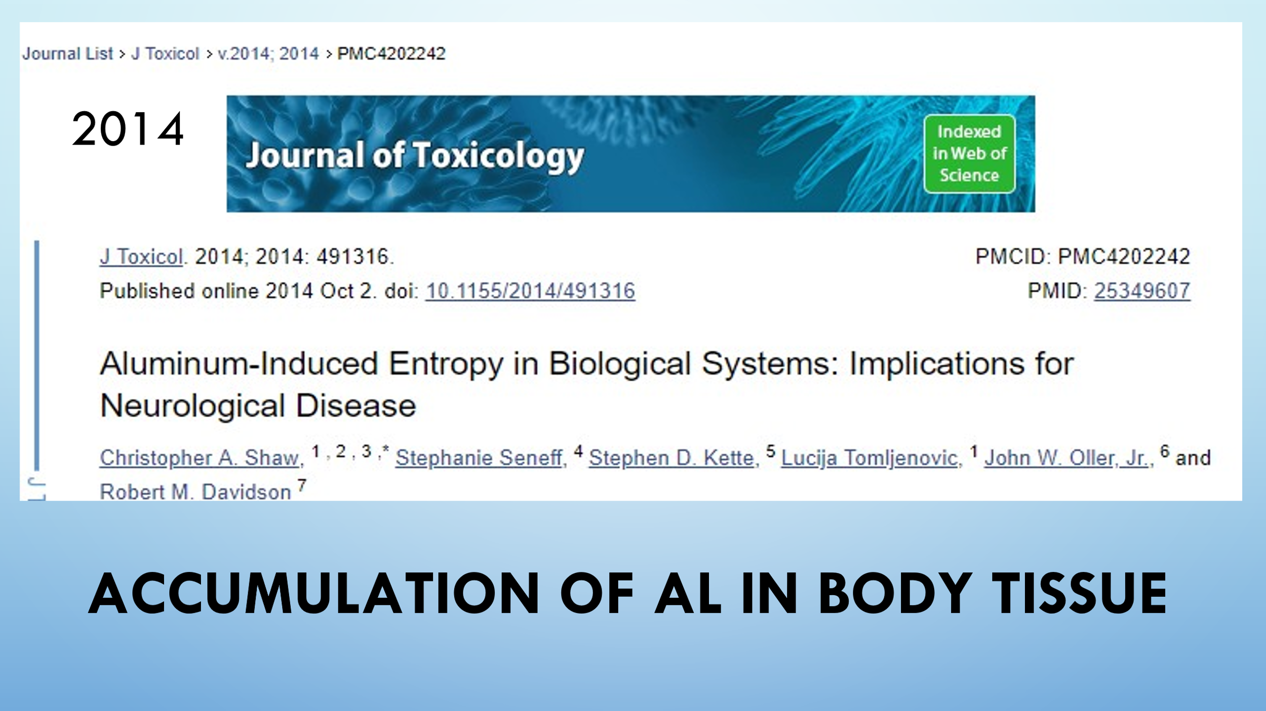

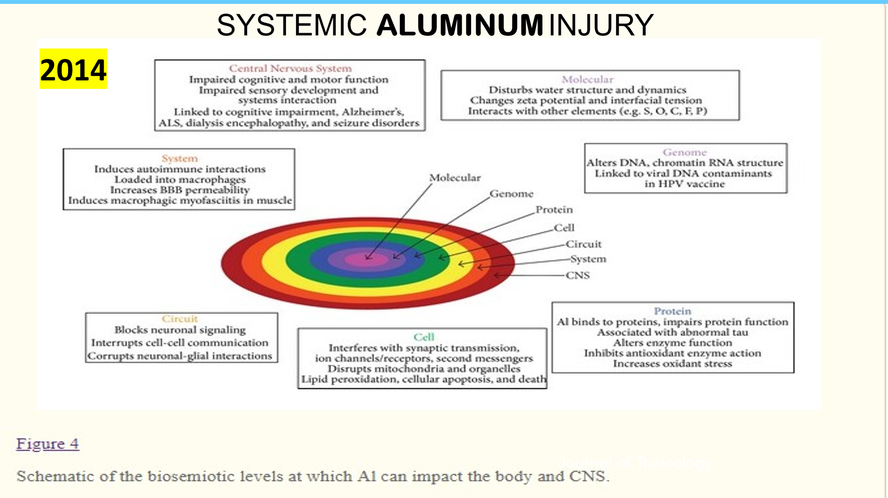

I downloaded this Systemic Absorption and Accumulation of Aluminum study to Chatbot on 7-10-2025 and this is what I got back:
- The aluminium content of these tissues was measured by an established and fully validated method [13] that herein is described only briefly. Thawed tissues were cut using a stainless steel blade to give individual samples of ca 0.3 g (3 sample replicates for each lobe except for hippocampus where the tissue was used as supplied) wet weight and dried to a constant weight at 37 °C. Dried and weighed tissues were digested in a microwave (MARS Xpress CEM Microwave Technology Ltd.) in a mixture of 1 mL 15.8 M HNO₃ (Fisher Analytical Grade) and 1 mL 30% w/v H₂O₂ (BDH Aristar).

- Digests were clear with no fatty residues and, upon cooling, were made up to 5 mL volume using ultrapure water (cond.<0.067 μS/cm). Total aluminium was measured in each sample by transversely heated graphite furnace atomic absorption spectrometry (THGFAAS) using matrix-matched standards and an established analytical program alongside previously validated quality assurance data [13].

- “This schematic presents a viewpoint that systemic aluminum exposure can have far-reaching consequences, affecting molecular processes, genetic material, cellular function, neural circuitry, and the central nervous system. Some researchers and advocacy groups use schematics like these to argue for more thorough research into the systemic effects of aluminum in vaccines and other sources.”

When aluminum is bound to plasma proteins in the blood, the immune response involving white blood cells (leukocytes) depends on various factors, including the body's recognition of aluminum-protein complexes as potential signals of foreign or abnormal substances.
What is the role of white blood cells and aluminum?
- Recognition: Immune cells, like macrophages and dendritic cells, may recognize aluminum-protein complexes as foreign or potentially harmful, especially if the aluminum induces changes in the protein structure or creates chemical signals.
- Phagocytosis: These immune cells may engulf and attempt to break down the complexes.
- Inflammatory response: The immune system may release cytokines and other mediators, leading to inflammation, recruitment of additional immune cells, and subsequent immune activation.
- Potential allergy or hypersensitivity: In some cases, aluminum can act as an adjuvant (a substance that enhances immune responses), which might lead to heightened immune activity, especially if exposure is chronic or in specific sensitive individuals.
Overall immune response:
- The body may recognize aluminum bound to proteins as an unusual entity, leading to activation of innate immune responses.
- Repeated exposure or high levels could potentially provoke hypersensitivity reactions, inflammation, or other immune-mediated effects.
In summary:
White blood cells may become activated upon detecting aluminum-protein complexes, leading to phagocytosis, cytokine release, inflammation, and sometimes immune sensitization. The precise response varies based on exposure level, individual immune sensitivity, and other factors.

Part 4.
Historical Concerns Over Vaccinations
For decades, infant vaccines have been suspected at the #1 cause of Sudden Infant Death in healthy children. Unfortunately, this research has been suppressed and completely ignored. The necessary safety studies to “prove” vaccines do NOT cause respiratory failure and death has never been done.

I have attached some charts from books that discusses the use of the breathing monitors, developed in 1988, on infants who had a sibling who previously die of SIDS. The alarms would sound showing stress immediately following their vaccine.

The DTP vaccine was why so many people were suing the vaccine manufacture up until 1986, when President Ronald Reagan signed The National Childhood Vaccine Injury Act (NCVIA) in 1986, protecting them from litigation, and removing all financial liability of injury or death from all vaccine manufactures. We use a different DTaP now but we also give vaccines day of birth and between 38 – 40 first year of life. Accumulation has not been studied.

Book: Vaccines: Are They Really Safe and Effective by Neil Z. Miller published 2001 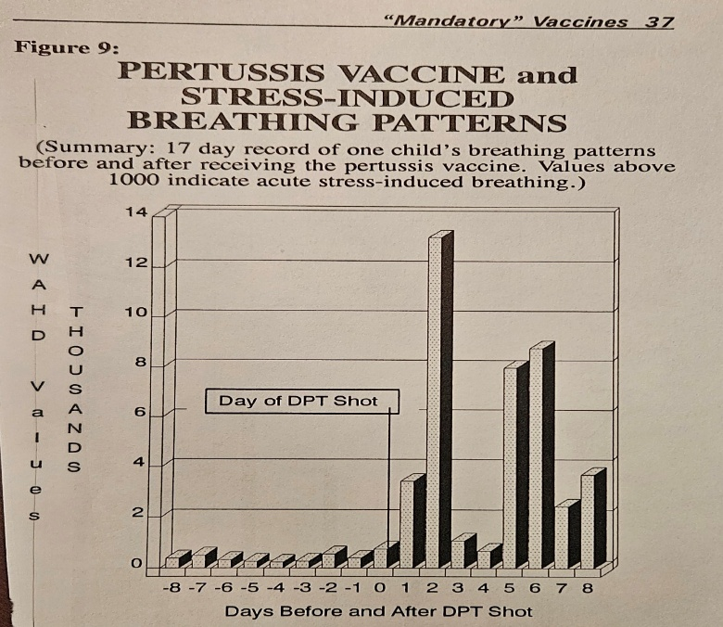 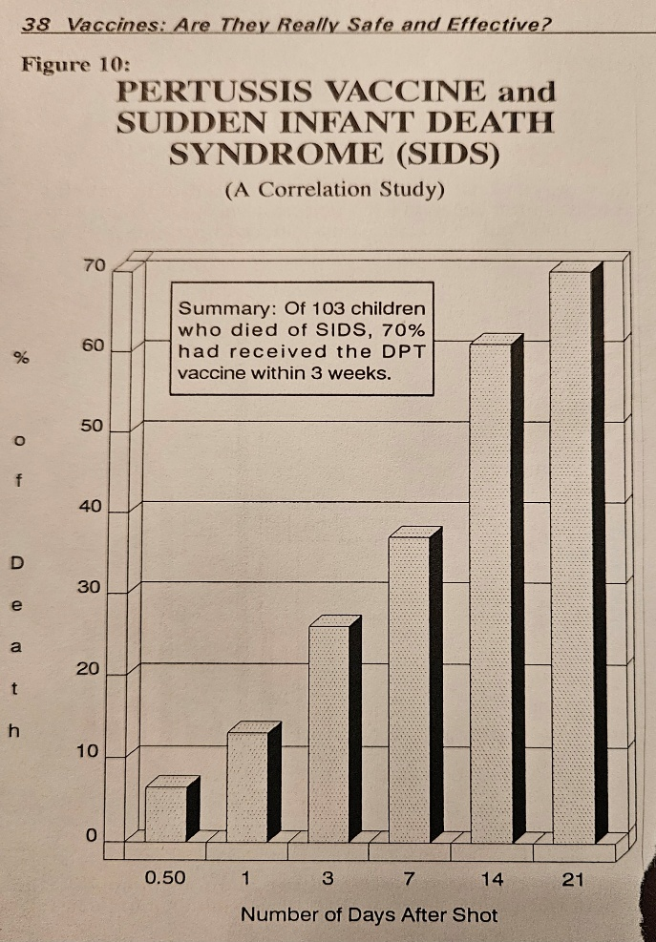

The only study ever done on aluminum prior to it being increased on the vaccines (2003) was in premature infants and the parenteral nutrition given. I was shocked to learn about this “nutrition” as having high aluminum levels!

Part 5.
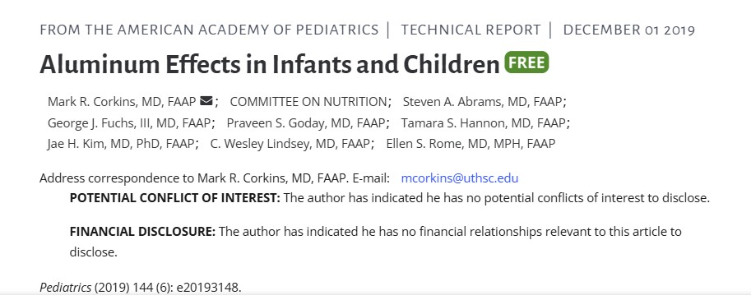
Background
Aluminum (Al) is a well-established neurotoxicant. However, little is known about its effects on the neurodevelopment of infants.
Objectives: To examine early-life exposure to Al in relation to neurodevelopment in healthy infants.
Methods: Nail Al concentrations were measured among 747 newborn babies within 6 months of delivery in the Shanghai Birth Cohort. Neurodevelopment was assessed using Ages and stages questionnaire (third edition, ASQ-3) at ages 6 and 12 months. General linear regression models were performed to estimate the associations between Al concentrations and ASQ-3 scores.

ASPEN STUDY- 1994
American Society for Parenteral (intravenous) Nutrition and
Enteral Nutrition
"Response of preterm infants to aluminum in parenteral nutrition" was published in the Journal of Parenteral and Enteral Nutrition (JPEN) in the September-October 1989 issue, according to the National Institutes of Health (NIH). This study, conducted by Koo et al., specifically focused on the impact of aluminum in parenteral nutrition solutions on premature infants. (I have observed that the original study by ASPEN has been manipulated since the first study was done in September 1989)
It was published by the American Society for Parenteral and Enteral Nutrition (ASPEN), according to the Journal of Parenteral and Enteral Nutrition. Response of Preterm Infants to Aluminum in Parenteral Nutrition Sep 1, 1989 — Response of Preterm Infants to Aluminum in Parenteral Nutrition - Koo - 1989 - Journal of Parenteral and Enteral Nutrition JPEN J Parenter Enteral Nutr. 1989 Sep-Oct;13(5):516-9. doi: 10.1177/0148607189013005516.
The Conclusion : Aluminum levels above 20 micrograms is toxic and lead to renal failure and the children who got the full level of aluminum showed signs of neurological delays at 18 months.
Note: The first vaccine given to infants’ day of birth, Hep. B vaccine, has 250 mcg of aluminum and by the time a child is18 months old and fully vaccinated, they would have received 4,925 micrograms of aluminum.
Some referenced studies for your consideration: Hopefully, these studies have not been removed like so many have. Here is the title for your search:
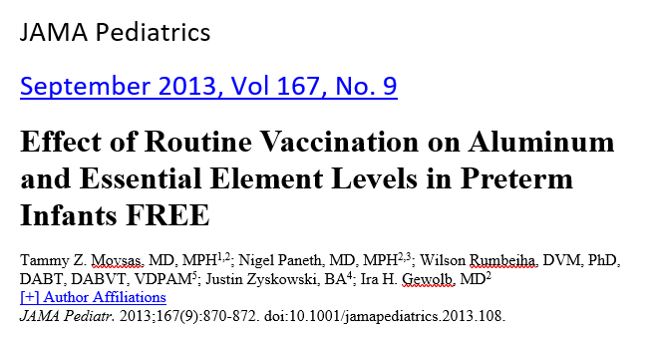
Parenteral feedings containing more than 4 to 5 µg/kg/d of aluminum have been shown to result in neurodevelopmental delay in preterm infants.¹ However, an infant at the 2-month checkup receives multiple aluminum-containing vaccines that in combination may have as high as 1225 µg of intramuscular aluminum; this is a much higher intramuscular aluminum dose than the safely recommended intravenous aluminum dose.² Our first objective was to measure prevaccine and postvaccine levels of aluminum in preterm infants, a population at higher risk of aluminum neurotoxic effects. Our second objective was to measure prevaccine and postvaccine levels of essential elements (EE). Inflammation from trauma can cause declines in serum levels of specific EE such as zinc and selenium³⁻ ⁵; there may be similar EE perturbations secondary to vaccination-induced inflammation.

METHODS
After institutional review board approval and parental consent, 15 preterm infants scheduled for routine 2-month vaccinations while still hospitalized were recruited in the Sparrow Hospital neonatal intensive care unit in East Lansing, Michigan. One day prior to scheduled vaccination, 0.25-mL blood and 12-hour urine collections were obtained. Prevnar 13, PedvaxHIB, and Pediarix vaccines were administered, in total containing 1200 µg of aluminum, as determined by company literature and confirmed by testing a set of these vaccines in our laboratory. One day postvaccination, 0.25-mL blood and 12-hour urine collections were obtained. Aluminum and EE concentrations were quantified by inductively coupled plasma mass spectrometry in serum and urine. Urine data were normalized using creatinine concentration. Two-tailed P values <.05 on paired t tests (SAS software; SAS Institute Inc) were considered significant.

RESULTS
No significant change in levels of urinary or serum aluminum were seen after vaccination (Table). Significant declines were noted postvaccination in serum iron (58.1%), manganese (25.9%), selenium (9.5%), and zinc (36.4%) levels, as was a significant increase in serum copper level (8.0%). A rise in selenium level was the only significant urine change. No significant postvaccine urinary or serum level changes were noted for phosphorus, sulfur, potassium, cobalt, nickel, molybdenum, nickel, or sodium. All participants had normal serum creatinine levels. 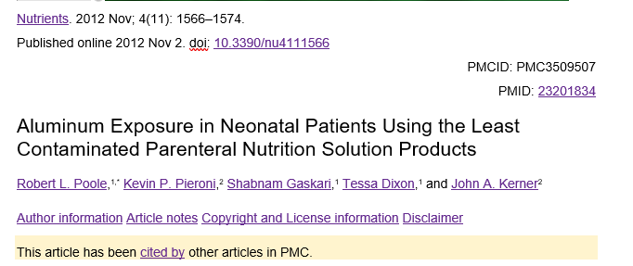
Question: Does that indicate that the aluminum was absorbed in tissues, organs and the brain? Is the premature kidney incapable of eliminating properly?

Premature infants are particularly at high risk of aluminum accumulation and toxicity as they often require PN for many days and have immature kidneys incapable of excreting aluminum efficiently.”
1. Federal Register, 2000; 65:4103 to 11.
2. Federal Register, 2002; 67:52429 to 31.
3. ASCN/A.S.P.E.N. workgroup on standards for aluminum content of parenteral solutions. Am J Clin Nutr. 1991;53:399– 402. Available at: http://www.naspgn.org/sub/position_papers/aluminum.asp
Conclusion: “In light of the potential link between aluminum contamination of parenteral solutions and morbidity among patients receiving parenteral nutrition, the FDA is issuing a rule to regulate aluminum content and to establish labeling requirements for large and small volume parenterals used in the compounding of parenteral nutrition solutions. All healthcare providers involved in the provision of parenteral nutrition should ensure that aluminum exposure is limited, when possible, in at-risk populations. Patient monitoring for aluminum toxicity may not be possible or reliable in most settings.”
Unanswered Questions that need to be address: How would this apply to the average newborn infant weighing 6 – 7 pounds and how would we know since no studies have been performed?
At what age do the kidney function optimal for eliminating the huge toxic burden from vaccines, considering we have never injected so many man-made ingredients, bioengineered chemicals first day of life and every couple of months for the first two years of life? This has never been done in the history of humanity and I believe if we are looking closely, we will recognize the extreme consequences in the last two generations.
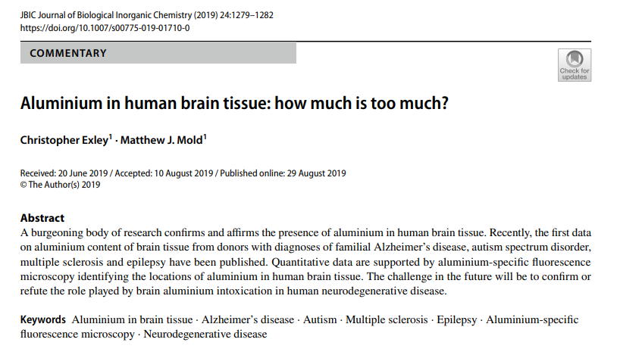
NOTE: The children who died with autism showed high levels of aluminum. This is an example of brain tissue absorption. Can we assume that other organs and tissues also had aluminum accumulation? This is rarely considered or studied when discussing the huge amounts of aluminum in the first 18 months of life in the recommended vaccines, (4,925 micrograms). By the time a child is 18 years old, it is approximated that they would have been exposed up to 9,000 micrograms of aluminum from recommended vaccines.

My Own Thoughts and Conclusions:
I cannot understand how ethical, well-educated individuals who are supposed to be the authorities on all these subjects are not aware of the catastrophic danger our children face through the mandatory vaccine program in the USA.
- I am asking for an immediate moratorium on all mandated vaccines for children under the age of two years old.
- I am requesting that the proper autopsies, including Systemic Absorption and Accumulation of Aluminum study be performed, and molecular and genetic testing considered, for identifying any metals or other toxins on all children that die suddenly two years or younger.
- I want to see educational training conferences for coroners and those who perform autopsies, on new protocols that would include comprehensive interviews including recent medical visits, vaccine records and medications that were prescribed.
- The 1986 vaccine liability bill be overturned or revoked so that pharmaceutical companies are once again held liable for their products like all other companies in USA.
- All new vaccinations will be required to go through real studies including double-blind placebo testing and long-term monitoring by neutral scientists without conflict of interests.
- Doing a statistical comparison of the SIDS/SUID with their Vaccinated V/S Unvaccinated state at time of death. It would be interesting to see how many children are fully/partially vaccinated with the recommended vaccines are dying compared to the unvaccinated. This would be a simple study to set up.

I do acknowledge the role of other environmental toxins that may play a role in SUID and other unexplained deaths.

As Robert Kennedy Jr. stated, all of our agencies are captured. Attorney Aaron Siri, Managing Partner, Siri & Glimstad, L.L.P., vaccine attorney, testified before a Senate hearing two months ago. He has been following everything related for years. He stated the following, “When Congress protected the vaccine manufactures from all liability, they removed all protection. Our health authorities are hopelessly conflicted. Congress gave them conflicted constructured duties; responsible for promoting vaccines, defending them in the Vaccine Compensation Program and you also asked them to be responsible for safety. Those conflict. One has taken over the other, they act like partners with pharma.” Safety studies have not been done for 38 years.

I am available for any questions or feedback. I have a full power point presentation I created following this brief that I intend to promote nation-wide. I would be happy to meet with you to give you more background information on this topic.

Respectfully,

Mary Tocco
843-708-3878
mary@marytocco.com

